1 Can you find and open the file manager program on the main menu or the task bar? *(Hint: It is under the Accessories sub-menu)*.

*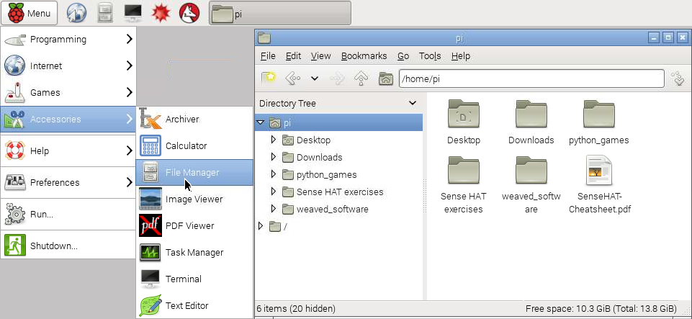*

2 Normally the file bowser will open up at the pi user’s home directory (remember you are logged in as the user named pi). Can you find where the file explorer shows you this piece of information?

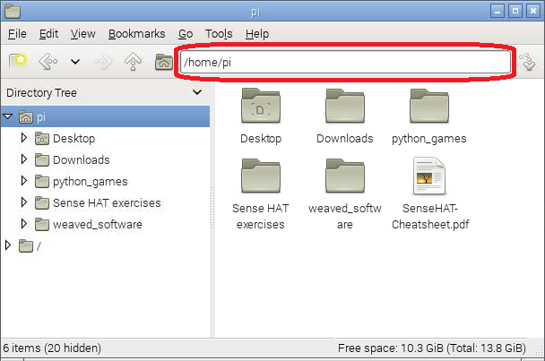

3 Your Mac or Windows computer usually has the C:/ location at the root, or top of all the other directories. This simply means that all other directories are contained within the C:/ directory. On the Raspberry Pi the root directory is called / (just a forwards slash). Can you use the file browser to navigate to the / directory?

4 Within the root directory you can see that the file explorer shows all the other directories and files that it contains.

